Stopsley Community Primary School and Nursery



‘Behaviour for Learning’ in every classroom

What is ‘Behaviour for Learning’?

Whilst it may look different in each year group, ‘behaviour for learning’ develops the key skills children need to master to become successful learners. Our 6 key behaviours build on our growth mindset ethos and show children how they can become more confident learners, who always aspire to do their best.

Why is Behaviour for Learning so important?

To be a successful learner, each child needs to develop key aptitudes that will enable them to access all their learning to the fullest extent. Our 6 key behaviours will develop skills and attitudes to learning that will put our children in good stead for the challenges they will meet throughout their lives. We are helping to build successful futures for all our children by showing them how to be highly motivated learners.

The six key behaviours for learning at Stopsley are represented by six wonderful animals:

The Wolf - Independence
The Ant - Collaboration
The Eagle – Challenge
Lion – Pride
Tortoise - Determination
Monkey - Curiosity

Each animal comes with their own story to illustrate their behaviour.

Each behaviour comes with a series of ‘I can…’ statements to help every child master them.

Every child can be rewarded with house points when they are demonstrating a behaviour well. As they accrue points, they are working towards their bronze (50 points), silver (100 points) and gold (150 points) learner badges.
Behaviour for Learning statements at Stopsley Community Primary School
Independence  (Wolf) | Collaboration  (Ant) | Challenge  (Eagle) | Pride  (Lion) | Determination  (Tortoise) | Curiosity  (Monkey)
 | 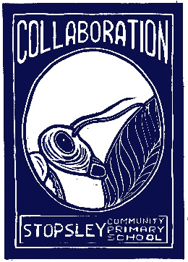 | 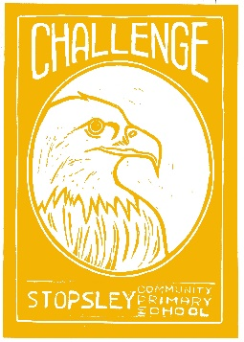 |  | 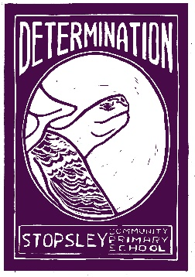 | 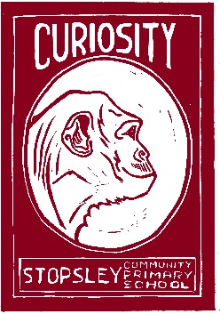
I can settle into learning quickly  I am not distracted easily  I can tolerate feelings without getting upset  I can use my initiative  I have a growth mindset  I can listen well  I can act on advice and feedback  I practise things I find difficult  I know my strengths and weaknesses  I can think about how I learn | I can share ideas  I can work well as a team  I can respond well to other people  I can listen well to others  I value ideas from others  I can explain to help others  I can ask for support when needed | I am motivated to do well  I can work really hard  I can challenge myself  I get on to extension tasks  I show a “limitless” attitude – never gets to an end  I always want more  I am competitive with myself  I like the feeling of being stretched | I feel pleased I’ve made progress  I follow “always” expectations  I always aim for very best  I am keen to impress  I enjoy learning  I sit in a good work mode  I don’t continue to receive the same next steps  I can ask questions  I can put my hand up regularly and contribute answers  I can talk about learning | I show perseverance  I am not put off by being stuck  I always try my hardest  I try different strategies  I start on task quickly  I always have a go  I show resilience  I don’t worry if it goes wrong  I keep improving | I often wonder “why?”  I can ask questions  I try to find out why  I can looks for patterns and connections and make links  I notice things  I become engrossed in what I am doing  I am excited to try new things  I can share and show things  I have a “what next?” attitude

Linking Values to ‘Behaviour for Learning’ at Stopsley Community Primary School
Independence  (Wolf) | Collaboration  (Ant) | Challenge  (Eagle) | Pride  (Lion) | Determination  (Tortoise) | Curiosity  (Monkey)


Values are an integral part of our personal development and a reflection of our humanity. They support the personal, social and emotional development of everyone. Can you see how the values listed below could be linked with our six positive Behaviours for Learning? Have a go at matching a value to our learning behaviours and write them in the boxes underneath each. Each value might relate to all, some or one learning behaviour.

Values:
Empathy
Fairness
Faith
Forgiveness
Friendship
Gratitude
Harmony
Health
Honesty

Hope
Humour
Integrity
Kindness

Love
Patience
Positivity
Reliability

Resilience
Responsibility
Respect
Tolerance
Unity

