Please help us to raise some money to build a sensory and relaxation garden for the children which will be an alternative outdoor learning space focussing on the five senses. We are also raising money to transform the corridors and classrooms into innovative and inspiring learning environments.
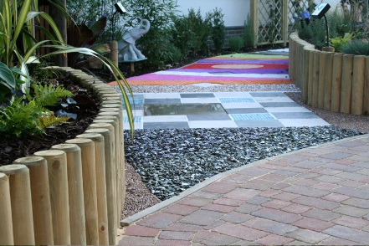

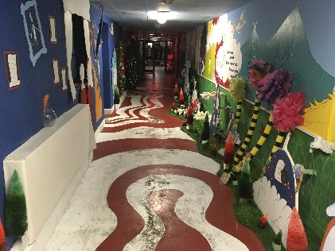

For further information or to make a secure donation, please visit https://www.justgiving.com/crowdfunding/stopsley-sensory-garden
Thank you!!
The Stopsley Team

