

FLAG BREAKFAST AND AFTER SCHOOL CLUB

General information
We aim to provide a happy, safe, stimulating environment where your child can have fun, learn and make new friendships in an out of school setting.
FLAG club is run by Stopsley Community Primary school and Nursery and is based in the schools dining room. We are open every day the school is with the exception of training days.
Breakfast club runs from 8am-8.45am and is £3.50 per child for each session – We also offer an ‘early bird session’ which begins at 7.45am, this will be charged at an extra £1.00. Breakfast is served until 8.30am to ensure all children are able to eat and get into class with plenty of time. Please ensure you select the early bird session upon booking if it is required.
After school club runs from 3.25pm(reception) 3.30pm (KS2) till 5.30pm, the children are collected from their classrooms after the school day has finished.
The pricing for after school club is as follows:
3.15pm-4.30pm - £5.00 Reception
3.30pm – 4.30pm - £4.50 – Years 1 to 6
4.30pm-5pm - £3.00 – for all years
5.00pm-5.30pm – £3.00 - for all years
Staffing/contact details
Flag club Co-ordinator: Rachel Gallagher – 07933 943 657
Email: flagclub@stopsley.primaryluton.co.uk
All staff are DBS checked for their suitability to work with children.
Activities
At FLAG club we offer a range of different activities which we change around each day, such as board games, puzzles, kinetic sand, quizzes, balls, Polly pockets, chalk boards, white boards, football table, reading and activity books, colourings, seasonal crafts, paints and much more.
We want the children to be able to unwind at FLAG club as it can feel like a long day at school for some. All children are offered a snack at after school club (we usually do this at around 4.30pm).There is always a rolling snack that children are able to have if they are due to go home before snack time begins. This can be sandwiches with various fillings, crackers or rice cakes as well as fresh fruit, which is also available every day. If your child has any dietary, requirements please add this to your registration form so that we are able to make any alternative arrangements that may be needed.
Bookings
To register for FLAG club you will need to go to the Stopsley Primary School website and type in “FLAG club” in the search bar on the top right hand side of the page. Once you have clicked on the FLAG club page, please scroll to the bottom where 2 links will appear, one will be a booking form and the other will be a registration form – both of these will need to be completed to secure your child’s place.
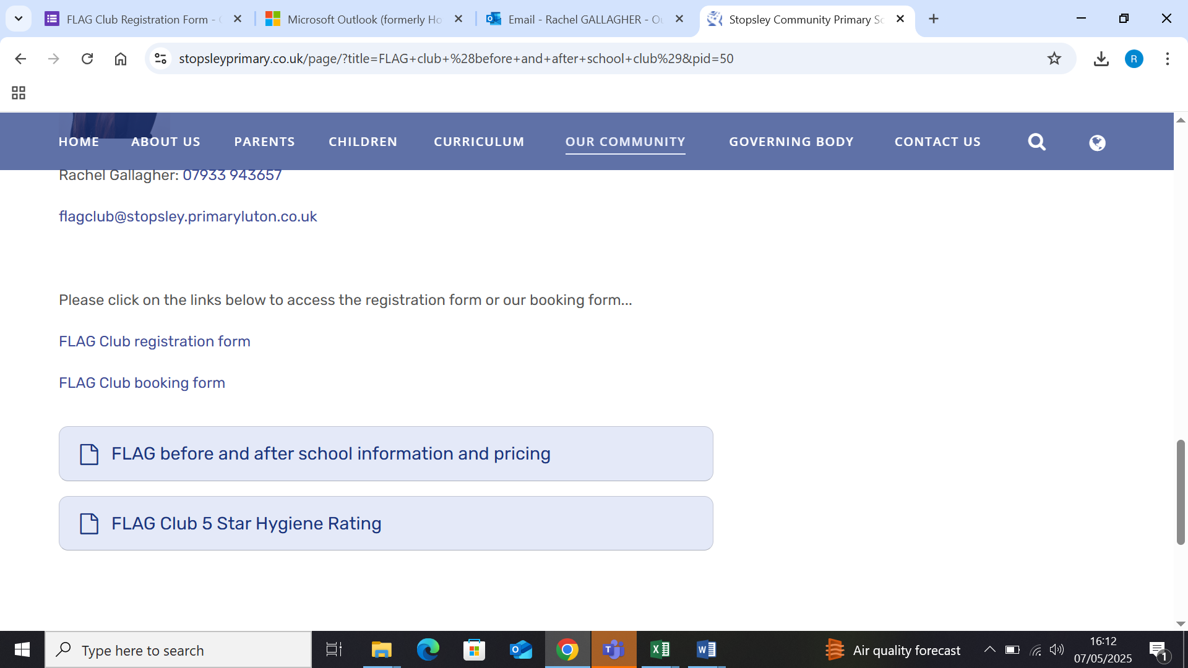
Once you have completed these forms your booking will be accepted, please assume your booking has been confirmed unless you hear from us.
Sessions can be cancelled with up to 24 hours’ notice without charge. Please be aware, sessions that are not cancelled within this time will be charged at the full rate of the session booked. We are happy to offer ad-hoc bookings but do advice booking as far in advance as you can as our spaces fill up quickly.

Early closure on a Friday (Rainbow club)
As you are aware the school closes early on a Friday afternoon. However, if you are a working parent and unable to collect at 1pm on a Friday, we offer our rainbow club. Rainbow club offers a variety of extra-curricular activities for children of all ages and is also run by our school staff. This runs from 1pm – 3.30pm and is free of charge. FLAG club then runs as usual until 5.30pm on a Friday afternoon after rainbow club has finished.
If you would be interested in registering your child to our schools rainbow club, please get in touch with Miss Gallagher on flagclub@stopsley.primaryluton.co.uk.
If you have any questions or queries regarding either club, please don’t hesitate to get in touch.

