 | 9.15  – 9.45 | 9.45-10.30 | 10.30 – 10.45 | 10.45 – 11.45 | 11.45 – 12.45 | 12.45-13.45 | 13.45 – 14.00 | 14.00 – 15.00 | 15.00-15.30
Monday | PE | Maths  Lesson 1 | B | English  lesson 1 and 2 | L | Science – see link | B | English – Lesson 3 and 4 | Reading – silently or with a grown up additional – see link
Tuesday | PE | Maths  Lesson 2 | R | English  lesson 5 | U | Computing – Purple Mash 2do | R | English – Lesson 6 | Reading – silently or with a grown up  additional – see link
Wednesday | PE | Maths  Lesson 3 | E | English – Lesson 7 | N | Music– see link | E | PSHE  Lesson 1 | Reading – silently or with a grown up  additional – see link
Thursday | PE | Maths  Lesson 6 | A | English – Lesson 8 | C | RE- See link | A | PHSE –  Lesson 2 | Reading – silently or with a grown up  additional – see link
Friday | PE | Maths  Lesson 7 | K | English – Lesson 9 and 10 | H |  | K
Year 2 Weekly Timetable for Home Learning WC 30/11/2020
To access the numbered lessons for each subject from this week’s timetable, please use the links below
Maths – Monday to Wednesday - https://classroom.thenational.academy/units/addition-and-subtraction-word-problems-cefb
Maths - Thursday and Friday - https://classroom.thenational.academy/units/addition-and-subtraction-of-2-digit-numbers-f192
English - https://classroom.thenational.academy/units/baba-yaga-created-story-openings-65a9
Reading - https://classroom.thenational.academy/units/the-unlucky-man-2e92
Music - https://classroom.thenational.academy/lessons/understanding-pulse-ctj3jc
RE- https://classroom.thenational.academy/lessons/what-is-the-christmas-story-6cwk4r
PHSE - https://classroom.thenational.academy/lessons/my-special-circles-cnk6ad -Lesson1
https://classroom.thenational.academy/lessons/one-big-family-74vp2e - lesson 2
Science - https://classroom.thenational.academy/lessons/which-materials-float-and-sink-cdj66c
Computing – 1. plan a short story – you could use the one you planned in English last week. Think about sound affects you could add – see example below. Use the chimp coding on purple mash to tell your story.
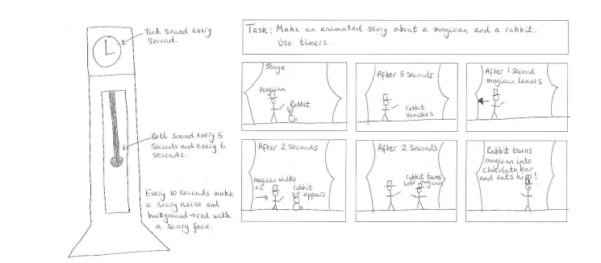
Additional ideas –
Free ebooks - https://home.oxfordowl.co.uk/reading/free-ebooks/
Phonics – use year 1 and phonics screening check revision videos. If your child struggles with reading use reception videos. - https://www.youtube.com/channel/UCP_FbjYUP_UtldV2K_-niWw/videos
Phonics - https://www.youtube.com/channel/UC7sW4j8p7k9D_qRRMUsGqyw
TTRS - https://play.ttrockstars.com/auth/school

If your child struggles to access the home learning for Maths and English please use these links –
Maths - https://whiterosemaths.com/homelearning/year-1/week-7-number-addition-subtraction/
English - https://classroom.thenational.academy/units/the-three-billy-goats-gruff-d801

